You are a Junior DevOps Engineer at a rapidly growing startup. The engineering team is expanding, and your CTO has noticed that the manual process of onboarding new developers is becoming a bottleneck. Currently, senior admins are wasting time manually creating users, setting up folders, and updating spreadsheets.
To demonstrate your scripting skills and improve team efficiency, you volunteered to automate this workflow. Your task is to build a robust Bash tool named onboard.sh. This tool will standardizes how new accounts are created, ensuring every new developer gets the exact same setup and that every action is automatically logged for compliance.
This challenge will test your ability to combine variables, conditional logic, exit codes, and file operations into a cohesive automation script.

Tasks
Create the Script File: Create a new file named onboard.sh in the ~/project directory.
nano ~/project/onboard.sh
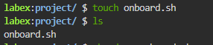
Make it Executable: specific permissions are needed to run the script.
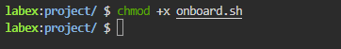
Check for Arguments: Add logic to check if the user provided exactly one argument (the username).
#!/bin/bash

# Check if a username argument is provided
if [ $# -eq 0 ]; then
echo "Usage: $0 <username>"
exit 1
fi

USER_NAME=$1
echo "User to be created: $USER_NAME"

chmod +x ~/project/onboard.sh

Handle Missing Arguments: If the argument is missing, print a usage message (e.g., Usage: ./onboard.sh <username>) and exit with a non-zero code (e.g., exit 1).
Store and Display Input: If the argument is present, assign it to a variable named USER_NAME and print a confirmation message (e.g., User to be created: <username>).

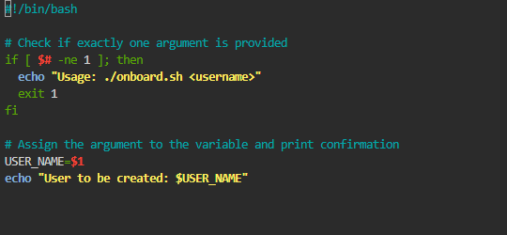

Output:
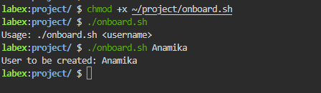

Explanation
- Shebang (#!/bin/bash): This line tells the system to use the Bash shell to execute the script.
- Argument Count ($#): This special variable holds the number of arguments passed to the script.
- Conditional Check (if [ $# -eq 0 ]): We check if the number of arguments is equal to 0. If meaningful arguments are missing, we should not proceed.
- Error Exit (exit 1): We print a usage message and exit with a non-zero status code (1) to indicate that the script failed/did not run successfully.
- Variable Assignment (USER_NAME=$1): We assign the first argument ($1) to a readable variable name USER_NAME. It is best practice to capture arguments into named variables at the start of the script.

Pre-flight Logic: Check User Existence
Automation scripts must be "idempotent" or at least smart enough not to crash if run twice. Before you try to create a user, you must verify if that user already exists on the system. Attempting to create an existing user will cause the useradd command to fail and dirty your output.

Tasks
Check for Existing User: Use the id command to check if the username provided in the argument already exists on the system.
Handle Duplicate Users: If the user does exist, print a warning message (e.g., User <username> already exists) and exit the script with an error code.
Silence Output: Ensure the output of your check command (both standard output and error) is redirected to /dev/null.
Confirm Non-Existence: If the user does not exist, print a message indicating the script is proceeding (e.g., User <username> does not exist, proceeding...).
Requirements
Use id check for the user.
If the user exists, print a message and exit.
Silence the output of your check command so it doesn't clutter the terminal (send standard output and error to /dev/null).
Print a confirmation message if the user does not exist.
Check the username stored in USER_NAME, not a hard-coded name.
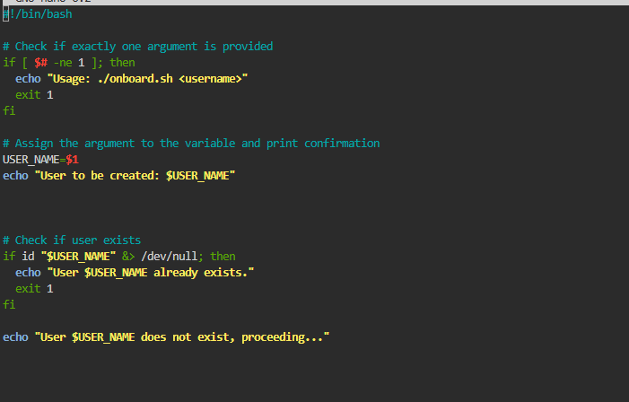
Output:
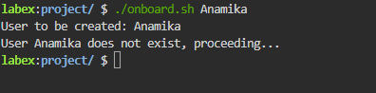
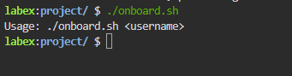

Core Task: Provisioning the Account
Now that safety checks are in place, implement the core functionality. You need to create the system user using standard administrative commands.

Tasks
Execute User Creation: If the user does not exist, proceed to create the account using sudo useradd.
Create Home Directory: Ensure the command includes the flag to automatically create the user's home directory.
Set Default Shell: Specify /bin/bash as the default shell for the new user.
Use Variables: Ensure you use the USER_NAME variable you defined earlier.
Add Feedback: Print messages indicating when user creation starts and finishes (e.g., "Creating user..." and "User created successfully.").
Requirements
Use sudo useradd.
Include the flag to create a home directory (-m).
Include the flag to set the shell to bash (-s /bin/bash).
Use the username variable you defined earlier.
Print status messages.

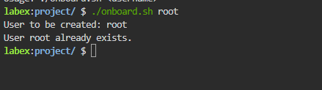

Step 2 Solution
1. Edit the Script
Open the existing onboard.sh file to add the user existence check:
nano ~/project/onboard.sh
2. Update the Code
Modify your script to match the following content. We added the section to check if the user already exists.
#!/bin/bash

if [ $# -eq 0 ]; then
echo "Usage: $0 <username>"
exit 1
fi

USER_NAME=$1

# Check if user exists
if id "$USER_NAME" &> /dev/null; then
echo "User $USER_NAME already exists."
exit 1
fi

echo "User $USER_NAME does not exist, proceeding..."
Save and exit nano (press Ctrl+O then Enter to save, and Ctrl+X to exit).
3. Execute the Script
Test the script with a user that definitely exists (like root or labex) to verify it detects collisions:
./onboard.sh root
Then test with a new user:
./onboard.sh newuser
Explanation
- Identity Check (id "$USER_NAME"): The id command checks if a user exists and prints their user info.
- Output Redirection (&> /dev/null): We don't care about the actual output of the id command, only whether it succeeds or fails. sending both Standard Output (1) and Standard Error (2) to /dev/null (the void) keeps our script's output clean.
- Exit on Success: If id succeeds (returns exit code 0), it means the user does exist. In this context, that's a collision, so we print an error and exit 1.
- Quotes ("$USER_NAME"): Always quote your variables to prevent issues if the variable is empty or contains spaces (though unlikely for a username).
- This check makes the script safer to rerun. Instead of blindly trying useradd and failing with a system error, the script explains the problem in a controlled way.

Core Task: Provisioning the Account
Now that safety checks are in place, implement the core functionality. You need to create the system user using standard administrative commands.

Tasks
Execute User Creation: If the user does not exist, proceed to create the account using sudo useradd.
Create Home Directory: Ensure the command includes the flag to automatically create the user's home directory.
Set Default Shell: Specify /bin/bash as the default shell for the new user.
Use Variables: Ensure you use the USER_NAME variable you defined earlier.
Add Feedback: Print messages indicating when user creation starts and finishes (e.g., "Creating user..." and "User created successfully.").
Requirements
Use sudo useradd.
Include the flag to create a home directory (-m).
Include the flag to set the shell to bash (-s /bin/bash).
Use the username variable you defined earlier.
Print status messages.

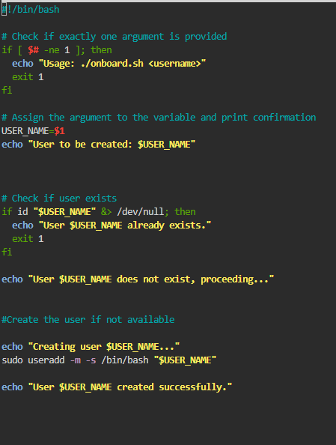

Output :
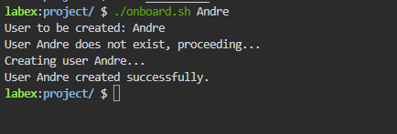

Environment Setup: The 'Work' Directory
A raw user account isn't enough. The development team convention mandates that every engineer has a dedicated work folder directly inside their home directory to organize code repositories.
Tasks
- Create Directory: Use sudo mkdir to create a work directory inside the new user's home folder (e.g., /home/<username>/work).
- Fix Ownership: Since the directory was created with sudo (making it owned by root), use sudo chown to change the ownership of this new directory to the new user and their group.
- Add Feedback: Print messages indicating the directory setup (e.g., "Setting up work directory..." and "User setup complete.").
Requirements
- Create the directory using mkdir.
- The path must be dynamic: /home/$USER_NAME/work.
- Change ownership using chown to $USER_NAME:$USER_NAME.
- Print status messages.
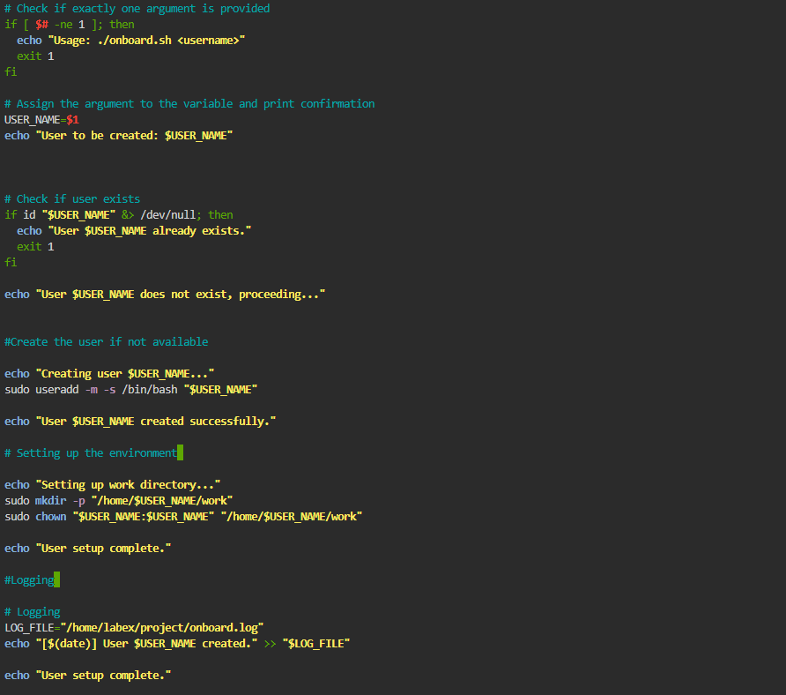
Output:

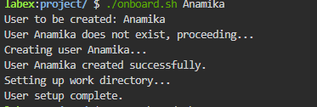

Summary
Congratulations! You have successfully built a production-ready automation tool.

In this challenge, you simulated a real-world DevOps task: taking a manual, error-prone process and turning it into a reliable, one-command solution. You practiced:

Input Validation: Preventing the script from running blindly with missing info.
Idempotency Checks: Verifying state (does the user exist?) before acting.
System Provisioning: Automating admin commands (useradd, mkdir, chown).
Audit Logging: Maintaining records for compliance.
These patterns—Validate, Check, Act, Log—are the pillars of robust system automation scripting.

